23.86: a) The two daughter nuclei have half the volume of the original uranium nucleus, so their radii are smaller by a factor of the cube root of 2:
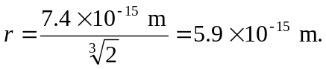
b) 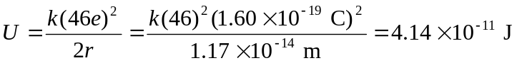
Each daughter has half of the potential energy turn into its kinetic energy when far from each other, so:
c) If we have 10.0 kg of uranium, then the number of nuclei is:
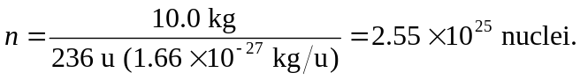
And each releases energy

d) We could call an atomic bomb an “electric” bomb since the electric potential energy provides the kinetic energy of the particles.

